PharmaSUG 2021 - Paper XX-###

Automating CDISC Terminology Downloads and Maintenance using Python and PowerShell

Melanie Logan, Samumed

# Abstract <heading 1>

Are you tired of manually downloading, distributing, and maintaining CDISC Terminology files? Using Python’s Selenium package and Windows PowerShell, you never have to open the browser, download, store, rename, move, or convert files again! In this paper, we explore one method for automating CDISC SDTM and ADaM terminology maintenance for clinical programming. We also step through how to set up automated execution of the program using Windows Task Scheduler. By the end of the paper, you will be comfortable in knowing how to utilize these tools for CDISC terminology file maintenance, along with any other file maintenance tasks that fit your needs.

# Introduction <heading 1>

Do not change the heading style or the text “INTRODUCTION” of the preceding heading. Replace the following text with one or more paragraphs of an introduction that explain the purpose and scope of your paper and provide readers with any general information that they need to understand your paper.

1. Purpose & Scope

As you write, consider the following:

* Keep your audience members (their skill levels, industries, and job roles) in mind.
* Identify what skills or knowledge your audience will gain.

# First Main Topic <heading 1>

This is a main topic in the body of the paper. This paragraph uses the PaperBody style.

If you need to include source code, introduce it with a sentence that ends with a colon:

proc ds2;

data _null_;

method init();

dcl varchar(16) str;

str = 'Hello World!';

put str;

end;

enddata;

run;

quit;

The easiest way to insert code is to copy the preceding code and modify it as needed. Be sure to indent the first line of code three spaces. Other lines can be indented for clarity. Certain words might be in a different color. You can keep the color or change it to black.

When you want to continue text after source code, select the PaperBody paragraph style. (See the section “To select a paragraph style.”

When including code in your paper, please maintain consistent capitalization conventions throughout the paper.

Figure 1 is a sample figure.

Always introduce a figure by inserting a cross-reference. For instructions, see the section “To insert a cross-reference.”

Figure 1. Caption for Sample Figure

Always use the Caption paragraph style for figure captions. See the section “To insert a caption.” Following those instructions ensures that the figures are automatically numbered (even if you rearrange them later). Use title style capitalization for captions (as shown in this example). For instructions about inserting a graphic, see the section “To insert a graphic from a file.”

## Subhead A Level <heading 2>

This is a subtopic of a main topic. This paragraph uses the PaperBody style. This paragraph uses the PaperBody style.

Table 1 is a sample table.

Always introduce a table by inserting a cross-reference. For instructions, see the section “To insert a cross-reference.”

| SAS Variable Format | DB2 Data Type |
| --- | --- |
| $*w*.  $CHAR*w*. | CHARACTER |
| any date format | DATE |

Table 1. DBLOAD Procedure: Default DB2 Data Types for SAS Variable Formats

Always use the Caption paragraph style for table captions. See the section “To insert a caption.” Following those instructions ensures that the tables are automatically numbered (even if you rearrange them later). Use title style capitalization for captions (as shown in this example).

# Second Main Topic <heading 1>

This is a main topic in the paper. This paragraph uses the PaperBody style. This paragraph uses the PaperBody style.

If you need to include a numbered (ordered) list, copy the following list, paste it, and modify the text. Be sure to introduce your list with a complete sentence that ends with a colon. For example, “Here are the required steps:”.

1. This is a sample numbered or ordered list item. This is list item text. This is list item text. This is list item text.
2. This is a sample numbered or ordered list item. This is list item text.

This is another sample paragraph. This paragraph uses the PaperBody style. This paragraph uses the PaperBody style.

If you need to include a bulleted (unordered) list, copy the following list, paste it, and modify the text. Be sure to introduce your list with a complete sentence that ends with a colon. For example, “Systems that are supported by the product include the following:”.

* This is a sample bulleted list item. This is list item text. This is list item text. This is list item text. This is list item text.
* This is a sample bulleted list item. This is list item text.

This is a continuation of the body of the paper—after an unordered list. This paragraph uses the PaperBody style.

Display 1 is sample display or screen capture.

Always introduce a display by inserting a cross-reference. For instructions, see the section “To insert a cross-reference.”

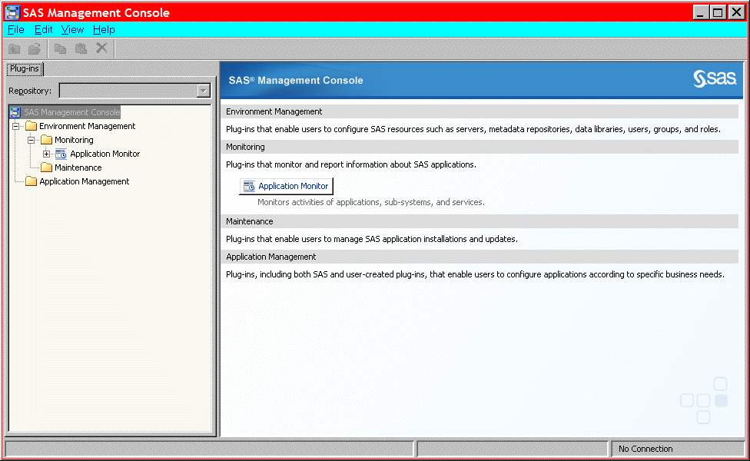

Display 1. Former Main Interface for SAS Management Console

Always use the Caption paragraph style for display captions. See the section “To insert a cross-reference.” Following those instructions ensures that the displays are automatically numbered (even if you rearrange them later). Use title style capitalization for captions (as shown in this example).

## Subhead A Level <heading 2>

This paragraph uses the PaperBody style.

Output 1 shows an example of how to present output.

Always introduce output by inserting a cross-reference. For instructions, see the section “To insert a cross-reference.”

CREATE TABLE ALLACCTX(SourceSystem varchar(4),

cctnum numeric(18,5) CONSTRAINT "ALLACCT_PK" PRIMARY KEY,

ccttype numeric(18,5),balance numeric(18,5),clientid numeric(18,5),

losedate date,opendate date,primary_cd numeric(18,5),status varchar(1))

Output 1. Output from a CREATE TABLE Statement

Always use the Caption paragraph style for output captions. See the section “To insert a caption.” Following those instructions ensures that the outputs are automatically numbered (even if you rearrange them later). Use title style capitalization for captions (as shown in this example). Note that output has the same font as source code, but it is in a box. (This box is not a text box.) The easiest way to properly format output is to copy the preceding output (including the box) and its caption, paste it, and then modify the text.

## Subhead A Level <heading 2>

This paragraph uses the PaperBody style.

### Subhead B Level <Heading 3>

This is a subtopic of a subtopic. This paragraph uses the PaperBody style.

#### Subhead C Level <Heading 4>

This paragraph uses the PaperBody style.

# Conclusion <heading 1>

Do not change the heading style or the text “CONCLUSION” of the preceding heading

This paragraph uses the PaperBody style.

The conclusion summarizes your paper and ties together any loose ends. You can use the conclusion to make any final points such as recommendations, predictions, or judgments.

# References <heading 1>

This section is not required. If you include this section, do not change the heading style or the text “REFERENCES” of the preceding heading.

The following references are examples and do not cover the spectrum of references that might be included. The important thing is to be consistent in formatting and organizing your references. If you prefer, you can follow a bibliographic approach such as the American Psychological Association (<http://www.apastyle.org/manual/index.aspx>) or the American Statistical Association (<http://amstat.tfjournals.com/asa-style-guide/>).

This is the format for references if you use the author-date format, in which citations are inserted in parentheses in text, such as (Smith 2014) or (Smith, 2014; Doe and Johnson, 2016). If the same author has several references, use a, b, c, and so on. For example, (SAS Institute Inc. 2015a, 2016b, and 2016c).

Book <Author name: last name, first name (or initials)>. <Publication date>. <*Book title*>. <City, State (abbrev) of publication> : <Publisher name>.

Journal article <Author name: last name, first name>. <Publication date>. “<Article title>.” <*Journal title*>, <volume no.:page numbers>.

Article in conference proceedings <Author name: last name, first name>. <Publication date>. “<Article title>.” <*Title of proceedings such as Proceedings of the SAS Global 2010 Conference*>, <City, State (abbrev) of publication> : <Publisher name>. Optional: You can add a URL to access available online proceedings. For example: Available at <http://support.sas.com/resources/papers/proceedings09/TOC.html>.

Website <Author name: last name, first name>. “<Title>.” <*Source*>. <Date>. Available at <URL>.

Reference examples:

Book Agresti, A. 2013. *Categorical Data Analysis*. 3rd ed. Hoboken, NJ: John Wiley & Sons.

Journal article Akaike, H. 1979. “A Bayesian Extension of the Minimum AIC Procedure of Autoregressive Model Fitting.” *Biometrika,* 66:237–242.

Article in conference proceedings Dorfman, A. H. and R. Valliant. 1993. “Quantile Variance Estimators in Complex Surveys.” *Proceedings of the Survey Research Methods Section*, 866–871. Alexandria, VA: American Statistical Association.

Website Federal Reserve Bank of St. Louis. 2012. “Economic Research.” Accessed November 7, 2012. <http://research.stlouisfed.org>.

# Acknowledgments <heading 1>

This section is not required. If you include this section, do not change the heading style or the text “ACKNOWLEDGMENTS” of the preceding heading.

This is the text for the acknowledgments. This paragraph uses the PaperBody style.

# Recommended Reading <heading 1>

This section is not required. If you include this section, do not change the heading style or the text “RECOMMENDED READING” of the preceding heading.

This is the format for recommended reading.

* *Base SAS® Procedures Guide*
* *SAS® For Dummies®*

# Contact Information <heading 1>

Do not change the heading style or the text “CONTACT INFORMATION” of the preceding heading. Do not change the text of the following paragraph. Replace all fields that are shown in angle brackets.

Your comments and questions are valued and encouraged. Contact the author at:

<Name>

<Enterprise (optional)>

<Phone (optional)>

<E-mail>

<Web (optional)

The next sentence is **optional** and applicable if you are including references to trademarked programs in your paper.

Any brand and product names are trademarks of their respective companies.

Remember to delete the following instructions and all other text that is highlighted in light tan.

# Basic Instructions

## Writing Guidelines

### Writing style

* Use active voice. (Use passive voice only if the recipient of the action needs to be emphasized.) For example:

The product creates reports. (active)  
Reports are created by the product. (passive)

* Use second person and present tense as much as possible. For example:

You get accurate results from this product. (second person, present tense)  
The user will get accurate results from this product. (future tense)

* Run spellcheck, and fix errors in grammar and punctuation.

### Citing references

All published work that is cited in your paper must be listed in the REFERENCES section.

If you include text or visuals that were written or developed by someone other than yourself, you must use the following guidelines to cite the sources:

* If you use material that is copyrighted, you must mention that you have permission from the copyright holder or the publisher, who might also require you to include a copyright notice. For example: “Reprinted with permission of SAS Institute Inc. from *SAS® Risk Dimensions®: Examples and Exercises*. Copyright 2004. SAS Institute Inc.”
* If you use information from a previously printed source from which you haven’t requested copyright permission, you must cite the source in parentheses after the paraphrased text. For example: “The minimum variance defines the distance between cluster (Ward 1984, p. 23)

## Tips for using Word

These instructions are written for MS Word 2007 and MS Word 2010. The steps are similar for MS Word 2003.

### To select a paragraph style

1. Click the HOME tab. The most common styles in your document are displayed in the top right area of the Microsoft ribbon. If you don’t see a style that you want, click the slanted down arrow at the bottom right corner of the Styles area, and scroll through the list. The main styles for this template are headings 1 through 4, PaperBody, and Caption. Avoid using other styles.
2. To change a paragraph style, click the paragraph to which you want to apply a style, and then click the style that you want in the ribbon.
3. PaperBody (used for most text) is automatically applied when you press Enter at the end of any heading style or the Caption style.

### To insert a caption

1. Click **REFERENCES** on the main Word menu.
2. Click **Insert Caption**.
3. Select the **Label** type that you want.
4. Click **OK**.

### To insert a cross-reference

1. Click **REFERENCES** on the main Word menu.
2. Click **Cross-reference**.
3. In the **Reference type** list box, select Heading, Figure, Table, Display, or Output.
4. For a heading:
   1. In the **For which heading** list, select the heading that you want.
   2. From the **Insert reference to** list, select **Heading text.**
5. For a figure, table, display, or output:
   1. In the **For which caption** list, select the caption that you want.
   2. From the **Insert reference to** list, select **Only label and number**.

### To insert a graphic from a file

1. Click **INSERT** on the main Word menu.
2. Click **Picture**.
3. In the Insert Picture dialog box, navigate to the file that you want to insert.
4. When the name of the file that you want to insert is displayed in the **File name** box, click **Insert**.